|  |
| --- |
| colored transparent rectanglebusiness center imagecolored transparent rectanglecolored rectangle  Market Analysis |

|  |
| --- |
|  |

|  |  |
| --- | --- |
| Word count: 5473  Email [Email Here] | [Related image](https://www.google.co.uk/url?sa=i&rct=j&q=&esrc=s&source=images&cd=&ved=2ahUKEwjl0NbNlLfjAhXt2eAKHW9xDSAQjRx6BAgBEAU&url=https%3A%2F%2Ftargetjobs.co.uk%2Fpostgraduate-providers%2Fhenley-business-school&psig=AOvVaw3e3AahdusNKjtGsEqepmc2&ust=1563288114293716) |

REMF48-18-9A

be832924

Contents

1.0 Executive Summary2

2.0 Introduction 3

3.0 Country Profiles 5

4.0 Core locations overview 17

5.0 Prime and Secondary assets in the core locations21

6.0 prime assets in the secondary locations 25

7.0 Emerging sectors in the secondary locations28

8.0 Overall recommendations30

9.0 References31

|  |
| --- |
| 1:0 Executive Summary |

* In this report CJCH are acting on behalf of our clients to gain insight into new and established markets.
* CJCH advise our clients about the prime office buildings in secondary non-prime locations in both **CANADA** and **SINGAPORE** that should provide a healthy reward to our investors
* These countries were chosen to diversify the portfolio by investing into different continents
* Diversifying the portfolio via different continents would also allow for strategic timing for economic cycles, thus, if holding periods would need to end sooner this would be highlighted
* Overall CJCH advise our clients the Global Real Investos to invest in:
  + - * + One student accomadation block
        + One prime office
        + One retail unit

|  |
| --- |
| 2:0 Introduction |

2:1 Project Outline

CJCH are working on the behalf of our clients the Global Real Investors in order to restructure their portfolio with a primary focus on allocating capital to non-core locations and assets. The Global Real Investors porfolio are already dominated by prime class A offices and shopping centres, CJCH aim to generate more income for our clients by taking advatage of emerging dynamic sectors.

CJCH are helping advice which sectors the Global Real Investors should invest in and locations that are worth investing in on a global scale in the next following years. This report aims to highlight the risks and opportunities within non-prime markets and recommend assets within good locations and sectors that will generate more income for the next coming years.

This report will focus on two countries: Singapore and Canada. These two countries have been chosen due to their geographical locations and avalibility of information. According to Bhalsod (2018) risk can be mitigated using target strategic timing of international property cycles. Harding & Pagan (2006) have measured the timings for continents that work well together to mitigate risk with Asia and North America showing high concordance levels. CJCH also believe there the information avalible to us at the time of doing this report was not limited; therefore, risk could be mitigated due to information transparency. At CJCH we believe stategic timing between Singapore and Candada as well as active management of the portfolio will generate more income for our clients the Global Real Investors.

2:2 Project Aims

* Assess the performance of prime office and retail assets within the capital cities of Singapore and Canada.
* Assess the performance of core assets the within the cities providing a comparitive benchmarking
* Assess the performance of prime assets in submarkets outside the capital cities within the countries
* Assess the performance of alternative asset classess that will increase income for the portfolio and compare which is best for the portfolio
* Provide a conclusive reccommendations for the client following what was found in the market analysis

|  |
| --- |
| 3:0 Country Profiles |

3:0 Selection stratergy

In order to pick the countries that would provide the good returns for the investment stratergy, CJCH have aimed to mitigate risk though diversification. CJCH have strategically chosen countries that are in different continents in order to mitigate any risks that would be faced if the portfolio was localised. CJCH have chosen Canada in the continent of North America and Singapore in the continent of Asia. These two continents were chosen due to their economic cycles being very similar to one another (Aviva, 2018). This means that as one countries economy increases in momentum, the other follows in pace shortly afterwards. This selection technique allows for strategic timing of holding periods in order to maximise revenue from the invested countries.

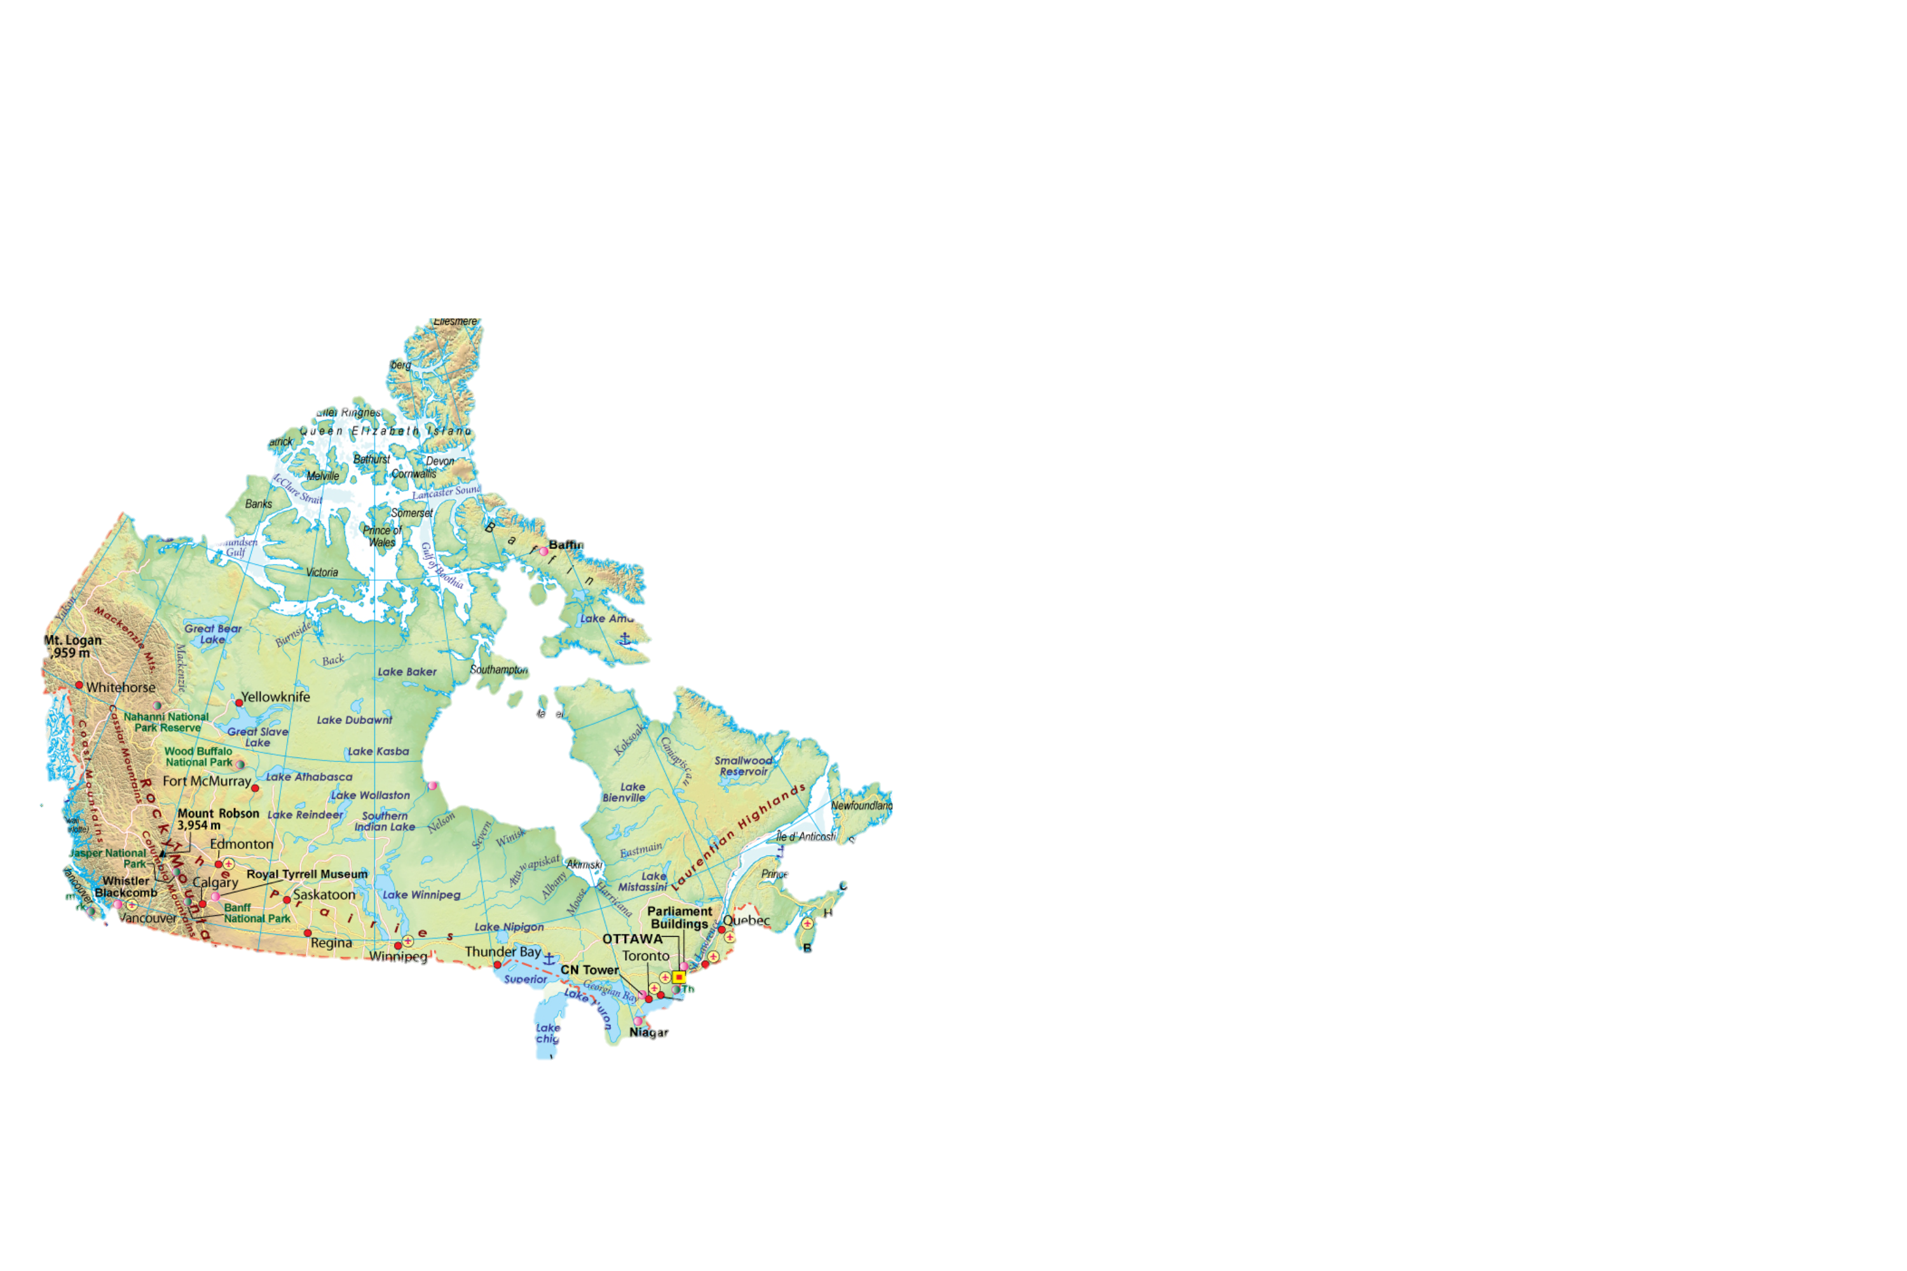CJCH also believe these markets are stable and have little political risk. Singapore and Canada also have attractive opportunities that will suit the need of our client.

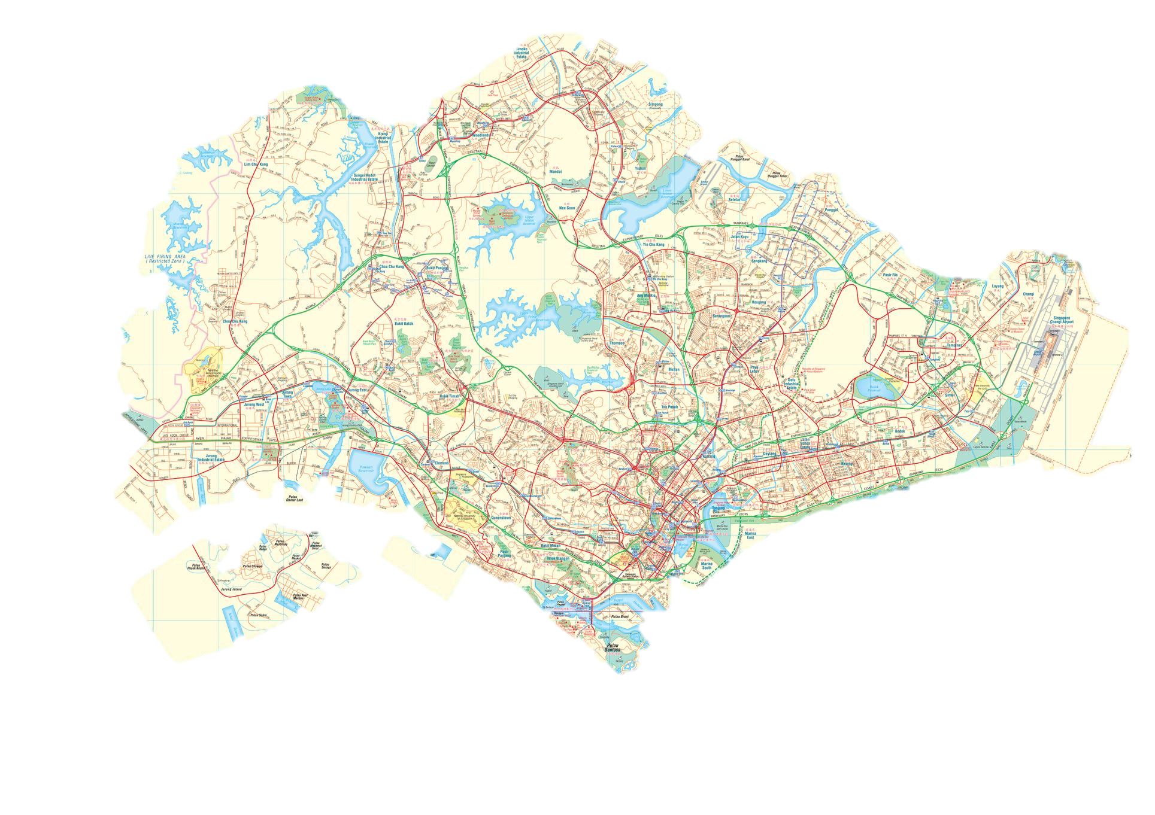

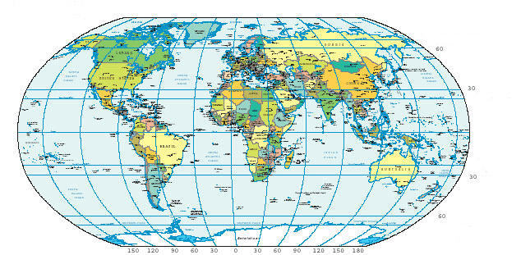

Figure : location of selected countries. Left - Canada and right - Singapore

3:1 Risk Assessment scale

In order to quantify risk throughout the report, a risk chart has been derived to assess low, medium and high risk. The countries and assets will be assessessed on the following criteria: Economic resilience, sustainability, investor growth, political stability and transparency.

* **Low risk = score of 0 – 1**

* **Medium risk = score 2 -3**

* **High risk = score 4 -5**

Figure : The Risk Assessment Chart

3:2 The Global Financial Crisis and Economonic resilience

3:2:1 Canada

Unlike most industrialised countries in the Global financial crisis, Canada had stregths which permitted it to weather the crisis better than the majority of other countries. Canada got through the financial storm relativly unscathed compared to the U.S and European countries. This was due to factors such as having a diversified banking system. Canada have adopted the “Universal bank” model which has allowed canadian banks to remain rather stable with healthy loan to deposit ratios. This is due to the model inheretly balancing assets and liabilities – the bank collects deposits from individuals and businesses and lends to both (Downe, 2010). This meant that though property had to be repriced it was not as significantly impacted as other European countries and the U.S (Gordon, 2017).

CJCH would regard Canada to have a high economic resilience as the impact of the global financial crisiss was not as hard to Canada as to other industrialised countries. This was due to factors such as the universal banking system having already evolved into the Canadian banking system, which provided protection for when the crisis hit. It is for this reason that we would give Canada 5 for economic resilience on the risk scale (see Figure 1).

3:2:2 Singapore

Singapore was the first east asian country to fall in a recession following the global financial crisis (Thagavelu, 2008). Though Singapore was impacted by the global financial crisis, their government was able to implement the Skills Programme for Upgrading and Resillience (SPUR) to recover from the recession quickly. SPUR allowed the Singaporean citezans to take programmes to acquire skills and knowledge in order to get jobs that would help speed up the economic growth of the country (Killiguou, 2010).

CJCH believe that though Singapore was able to recover from the global financial crisis quickly compared to other neighbouring countries; therefore, making Singapore a very buoyant and resilient country compared to other east asian countries. CJCH regard Singapore to be of medium to high economic resilience; thus, a score of 3 on the risk scale (see Figure 1.).

3:3 Sustainability

In order to better understand each countries sustainability levels the Brundtland (1987) definition has been adopted. This definition states that sustainabile practices should be used socially, economically and environmentally in order for a country to be sustainable.

3:3:1 Canada

As shown in Figure 3 employment is increasing 0.5% year on year for Canada. Canada was able to pass 62% employment for all Canadians over the age of 15 years old (CLC, 2019). As employment has been increasing since Q3 2018, this means there should be an increase in consumer spending. This is because people will have more disposible money to spend in shops. As well as this, employment increasing means there will be more need for office spaces for people to work in. This is good for the economic sustainability of Canada.

Figure : Employment rates in Canada. Source CLC (2019)

This is expected to keep increasing with canadas population on a steady increase since 1971 as shown below in Figure 4 (Wold’O’Metres, 2019). For these reasons CJCH believe Canada is sustainable and will be a good country to invest in for our clients therefore we are awarding Candada with a score of 4 on the economic sustainability scale (see Figure 2).

Figure : Population of Canada and Singapore between 1978 and 2018

3:3:2 Singapore

As shown in figure 5 employment has been growing each year in Singapore since 2010 (Economics, 2019). As well as this consumer spending has also increased (CBRE, 2019). Singapore is also very environmentally aware with making buildings sustainable. In 2016 Singapore Exchange introduced a mandatory sustainability reporting guide which needed to be followed for new developments in order to make the country more eco-friendly (Compact, 2016) . It is for these CJCH believe Singapore should be rewarded a economic sustainability mark of 5 (see Figure 2). Singapores growing population (see figure 4), imporving population rates and environmental awareness makes CJCH believe that the stability of Singapores economy will be highly sustainable throughout the investment project time phrame.

Figure : Singapore employment source: Trading Economics (2019)

3:4 Transparency

CJCH have adopted JLL’s Global Real Estate Transparency Index (2018) measure for transparency. The transparency index focuses on 10 key characteristics to measure transparency.

Figure : JLL Global Real Estate Transparency Index measurement criteria (2019)

Using this index Singapore is the 48th most transparent country out of the 158 cities assessed in the JLL (2018) report. This make Singapore the leading gateway city; however, it is still ranked outside the top tier of transparent countries. Canada has 3 cities in the top tier of the most transparent cities. These are Toronto at 23rd, Vancouver at 38th and Calgary at 36th. Therefore, CJCH feel it is appropriate to give a transparency score of 5 and 3 respectively to Canada and Singapore.

3:5 Political Stability

The Worldwide Governance Indictors have been used to measure political stability. This is measured on six broad dimensions: voice and accountability, political stability and absence of violence, government effectiveness, regulatory quality, rule of law and control of corruption. These 6 dimensions are political stability indicators with over 30 underlying data sources that have been complied together. Data is taken from reports and surveys and given a score between 0 (unstable) and 100 (very stable) (Indicators, 2019).

3:5:1 Canada Using the worldwide governance indicator statistics, Canada has been a score of 97.62. This indicated Canada is a very politically stable country and there is very little violence in comparison to other countries globally (Indicators, 2019). Therefore, CJCH feel Canada should be awarded a score of 4 on the political stability scale (see Figure 2).

3:5:2 Singapore

Singapore has also been measured using the political stability indicators. Singapore is one of 4 countries that have been given a perfect score of 100 (Indicators, 2019). CJCH feel it appropriate to award Singapore with a score of 5 on the political stability scale (see Figure 2).

3:6 Investors

3:6:1 Canada

National investment volumes totaled $7.7 billion in Q1 2019. The three most active asset classes by volume is office at $1.8 billion, multifamily at $1.4 billion and industrial with $1.9 billion. The primary demographic of investors are private Canadian investors, institutional and private equity groups. Toronto has been the most attractive investment market with volumes totaling $2.7 billion. This included the largest transaction in Canada – Dylnamic Funds Tower to GWL, Investor Group and OPTrust for $473.0 million. Vancouver and Montreal were following behind with $1.6 and $1.2 billion investment volumes.

Figure : Investment Volume by market. Source: CBRE (2019)

Notably there has been a lack of foreign investment which accounted for only 1% of all deals in the first quarter (CBRE, 2019). The focus from foreign investment that been towards long-term holding opportunities in trophy assets and new alternative investment opportunities (CBRE, Real Estate Market Outlook , 2019). It is for this reason CJCH have awarded an investor growth rating of 4, as there is lots of potential growth from overseas investment (See Figure 2).

Figure 8: Purchaser Profile: Source: CBRE (2019)

3:6:2 Singapore

Investment sales volumes increase 12.9% to S$6.1 billion in H1 of 2019 from S5.4 billion in H2 2018. The largest sale was of the Chevron House which sold for S$1.0 billion. Commercial had the highest amount of investment volumes totaling S$6 billion followed by residential at S$4.7 billion (Frank, 2019).

Figure : Property investment sectors, Source: Knight Frank (2019)

It is forecasted that Singapore’s low interest rates and stable exchange rate are likely to attract more overseas investors in next coming quarters. While commercial properties are likely to be the bulk of investments sales, though there is the additional buyers stamp duty places on foreign buyers, Singapore remains politically stable and has huge potential to upside; thus enticing overseas investors. It is for this reason CJCH are giving an investment growth rating of 5 to Singapore, this is because Singapore is a very stable market with huge growth potential to upside for investor (see Figure 2).

3:7 Country Overview

|  |  |  |
| --- | --- | --- |
|  | Canada | Singapore |
| Continent | North America | Asia |
| Capital City | Ottawa | Central Area (Pulau Ujong) |
| Population | 37.06 million | 5.61 million |
| Population growth | +1.2% | +0.1% |
| Citezens employed | 62.7% | -1.6% since 2018 |
| Economic resilience | * Not as impacted by the global financial crisis as other countries * Universal bank model * Stable loan to deposit ratio | * policies put in place to recover quickly from the global financial crisis * SPUR skills programme to invest in skills within the country |
| Sustainability | * 0.5% increase in employment year on year * Increases in consumer spending * Adoption of envionmentally sustainable develpments | * ‘adlopt or explain’ environmental policies implemented * Strong focus on social wellbeing * Policies such as SPUR to invest in citezens and skills to drive the economy |
| Transparency | * 3 cities in the top tier of JLL’s Global Real Estate Transparency Index * Rotonoto at 23rd * Vancouver at 38th * Calgary at 36th | * Ranked 48th in JLL’s Global Real Estate Transparency Index * First of all Gateway cities in Asia * Not in the top tier |
| Political stability | * Score of 97.62 (very stable) using the world wide governance indicators | * Score of 100 (very stable) using the worldwide governance indicators |
| Investor growth | * Foreign investments are very low at 1% * The three most active markets at toronto, Vancouver and Montreal | * The majority of investments are in commercial assets * Foreign investors have to pay additional buyers stamp dury * Prospects of upsising is attracting investors |
| Opportunities | * Opportunites to invest in assets that will be needed by employment growth * Opportunities to invest in environmental sustainability * Increasing consumer spending | * To build on environmental and social sustainability * Good chance to invest in order to upsize |
| Risks | * Very low foreign investment at 1% | * Employment is decreasing |

Overall CJCH believe these both countries have opportunities that will help mitigate risk when investing.

|  |
| --- |
| 4:0 Core locations overview |

4:0 Core Locations selection stratergy

When selecting the locations that are core to the country, CJCH have looked for cities that generate the highest income for the country. This is not necessarily the capital city.

4:1 Canada - Toronto

4:1 Canada – Toronto

Despite global uncertainty in the economic and political world, Toronto has established itself as one of the most stable and predominant business centers in the developed world. Toronto has experienced nine successive years of GDP growth since the global financial crisis, with 2018 experiencing a GDP growth of 2.7%. Toronto is recognized as a desirable destination for immigration with the market population increasing by 120,000 people in 2018. As well as this employment was at a all time low since the late 1990’s with only 6% of citizens over the age of 15 unemployed (CBRE, Real Estate Market Outlook , 2019).

4:1:1 Construction

Toronto is currently developing 8.1 million sq. ft of new office space and 2.6 million sq. ft. committed for development. This is the largest volume of development that has been undertaken in over 15 years. Demand for this new space has been healthy, with 61.5% of the 7.3 million sq. ft. that is currently under construction already being pre-leased by the end of 2018. As Toronto becomes increasingly recognized on the international scale, Grade A office space will become a key driver of future economic growth as well as a key player in attracting new businesses (CBRE, Canada Investment Q1 2019 Investment activity moderates briefly following late 2018 financial market volativity , 2019)

4:1:2 Vacancy rates

The end of 2018 saw the vacancy rate in Toronto ending at the lowest of any major markets North America with 2.7%. This drove the asking rent up by 14.2% for the average Class A space to $35.37 per sq. ft. Though the majority of large office spaces are leased by legal firms as well as financial and business services, it is forecasted that their will be a growing need for space from emerging industries in technology and coworking firms (Frank, 2019).

4:1:2 Omnichannel in retail

Online retailers are now starting to invest in brick and mortar. Forward-thinking retailers, both online and traditional are starting to understand the importance of customer experience. Retailers are understanding the importance of customers being able to touch and try products, while also being able to have the option of being able to buy online without entering a store. Online-only retailers are starting to see that digitally-native brands are not enough in this new environment thus are beginning to expand their businesses via brick and mortar space to better connect with consumers. This trend is forecasted to increase in the next coming years (International, 2019).

4:1:3 Investment

2018 saw the third consecutive record for investment volume in Toronto with just under $18.0 billion invested. While this may scare some investors due to late cycle caution and rising interest rates, momentum is continuing to increase, and demand is still buoyant (CBRE, 2019).

|  |  |
| --- | --- |
| Canada | |
| Opportunities | Risks |
| * Demand for new office space is healthy | * Already a lot of development in the pipeline for offices |
| * Demand from technology firms and emerging industries | * Long cycle – is it near ending? |
| * High demand for coworking spaces | * Rising interest rates |
| * Need for space due to very low vacancy rate of 2.7% |  |
| * Online brands moving to brick and mortar |  |
|  |  |

4:2 Singapore – Central Business District

4:2:1 Trade tensions

The US-China trade war may be a major source of volatility in the future for Singapore, though this was is yet to impact greatly. However, there is caution for a full-scale trade war scenario leading to a deterioration in confidence and investments which will impact the overall volumes of trade (CBRE,2019).

4:2:2 Interest Rates

The past 18-24 months have seen a prospect of rising interest rates with the federal reserve benchmark interest rates rising four time in 2018. As well as this local interest rates have also been on the rise, though at a manageable pace (CBRE,2019).

4:2:3 Key driver firms for office space

The co-working sectors were standout performers of 2018. With the co-working market doubling in size from 0.7 million sq. ft in 2017 to 1.4 million sq. ft. by the end of 2018. As well as this technology has seen a significant expansion in the market (CBRE, 2019).

4:2:4 Growth in the retail sector

Retail has seen a 6.6% year on year growth as of November 2018. With tourism forecasted to increase in the next 3 years, the retail sector is expected to continue growing. Though, there is still a level of uncertainty in the sector due to consumer confidence index not reaching the market optimism levels.

|  |  |
| --- | --- |
| Singapore | |
| Opportunities | Risks |
| * Economic growth of 3.3% | * Trade war between China and the US may impact Singapore |
| * Co-working, technology and start-up are on the rise | * Interest rates are rising at a slower pace |
| * 6.6% year -on -year growth in the retail sector | * Consumer confidence index is not as high as needed |
|  |  |

|  |
| --- |
| 5:0 Prime and Secondary assets in core locations |

5:0 Office market overview

5:0:1 Canada - Toronto

Toronto is currently the leading city in Canada for economic growth. With 30% of users in the Toronto office market coming from tech, Toronto is starting to transform into a leading technology-hub city. There is currently 8.1 million sq. ft of new office spaces being constructed. As well as this demand for grade A office space remains high with just over 61% of the office spaces being developed already pre-leased (CBRE, 2019).

5:0:1 Singapore - Central business district (CBD)

The central business district of Singapore saw the office market outperform expectations in Q2 of 2019. Vaccancy rates also decreased for Grade A office buildings. Co-working was the highest performer within the sector, with the co-working market almost doubling in size from 0.7 million sq.ft in 2017 to 1.4 million sq ft by the end of 2018 (Frank, 2019). There has been a vacancy tightening from6.2% to 5.1% at the end of 2018, this reflects a healthy take up of prime office spaces in the Central business district.

|  |  |  |
| --- | --- | --- |
|  | Toronto | Central Business District |
| Cap Rates | 4.5 -5% | 1.7-5.3% |
| Vaccancy rates | 2.5% | 5.1% |
| Rental growth | - | 14.9% |
| Average income sq. ft. | $36.75 | S$10.61/MO |
|  |  |  |

Figure : Statistics for prime office space in Canada and Singapore: Source CBRE (2019)

5:0:2 Cap Rates

Toronoto provides a stable cap rate within the prime offices ranging on average between 4.5% and 5%. While Singapore has a larger range for it cap rates. A recod low cap rate was achieved on a 999-year leasehold for the 55 Market Street office build, though cap rates on averrage are a high as 5.3% in the central business district (Wong, 2018).

5:0:2 Vaccancy rates

Vaccancy rates in Toronto have fallen to the lowest of all northern american cities at 2.5%. This has driven prime office spaces up in rent and is expected to increase demand for prime office supplyy.

Vaccancy rates for the Central business District of fell from 6.2% to 5.1%. Like Toronto this is expected to drive prices up for prime office space as well as increase office supply.

5:1 Opportunities and Risk

5:1 Toronto and the Central Business District

Both Toronto and the central business district have a high demand for new office spaces due to the tightening of vaccancy rates. Tecnology and emerging industry firms are increasingly showing interest in this market. As well as this there has been high demand for coworking spaces and online brands to move to invest in brick and mortar.

Investing in prime office space in Toronto as of right now does come with its risk due to the rising interest rates and that the increasing cycle might come to a halt any time soon. As well as this there is a lot of other development occuring in the pipeline right now, which will increase competition on which buildings will lease first while the other deterorate in obscelence.

Risk for the central business district is seen in the increasing interest rates; however, there is lots of room for investors to upsize within this market.

5:2 Retail market Overview

5:3:1 Canada – Toronto

There has been an increase in omnichannel retailing. This is increasing with the awareness that companies that only provide online goods are not as sufficent as those that use bick and mortar as well as online convinience (International, 2019). (See section 4:1:2 for more details).

5:3:2 Singapore – Central Business District

Retail has seen a 6.6% year on year growth as of November 2018. With a forecast of increased tourism in the next few years the central business district is expected to continue growing in the retail sector. (See section 4:2:4 for more details).

|  |  |  |
| --- | --- | --- |
|  | Toronto | Central Business District |
| Cap Rates | 4.5-6% | - |
| Vaccancy rates | - | - |
| Rental Growth | 4.2% | 6.6% |
| Net Supply (million sq. ft.) | 1.22 | 1.5 |
|  |  |  |

5:4 Notable Transactions of assets in the core locations

|  |  |  |  |  |  |  |
| --- | --- | --- | --- | --- | --- | --- |
| City | Name/ Address | Type | Price | Size | Purchaser | Benchmark  1= poor  5= Ecellent |
| Toronto | Dynamic Funds Tower | secondary | $473 million | 650,000 sq. ft. | GWL, Investors Group, OPTrust | 2 |
| 56 Wellesley St W | prime | $98 million | 216,000 sq. ft | GWL, Canada Life, London Life | 4 |
| Singapore | 9 Penang Road | prime | 381,000 sq. ft | - | UBS Singapore | 5 |
| Mina Bay | secondary | 30,000 sq. ft | - | Mead Johnson | 3 |

CJCH would recommend our clients to invest in these assets as they fit the proposal of what our clients want. CJCH believe these assets will provide a high return and are of medium risk which has been mitigated due to investing internationally.

5:4 SWOT analysis of Core locations

* Tightening vaccancy rates
* Global Uncertainty
* Coworking spaces are high in demand therefore refurbishment will be needed
* High demand for Grade A office spaces

|  |
| --- |
|  |

CJCH would advise our clients to be mindfull of the threats and weaknesses that have been presented in our market analysis. Though we believe that the stregths and opportunites outweight the weaknesses.

|  |
| --- |
| 6:0 Prime assets in secondary locations |

6:1 Office Market overview

6:1 Canada – Vancouver

The office market in Vancouver is thirsting for new builds, as vaccancy rates are at an all time low of 3.8%. Vancouver is currently between development cycles with new supply pushing the rental rates to the highest levels ever experienced as well as the vacancy rates down. 4.1 million sq. ft of new office space is in the pipeline and set to be delievered by 2023.

As a result of the strong leasing activities that are taking place in the office market, the investment into commercial looks positive for 2010. Cap rates are continuing to remain at the lowest ever seen due to leasing strengths in the Vacouver market. Foreign capital is remaining an active player in the Vacouver market with a new focus on emerging sectors, developable land and trophy assets (CBRE, 2019).

6:1:2 Singapore - Central Boulevard

The office market in Central Boulevard has seen a sharp increase in growth with vaccancy rates decreasing for the 3rd year in a row to 7%. Central Boulevard is a location that is attracting many investors due to the cheap price of S$6 sq. ft. MO compared to the central business district. Central Boulevard is attracting many start up businessnesses as well as smaller technology and legal firms (Savills, 2018).

|  |  |  |
| --- | --- | --- |
|  | Vancouver | Central Boulevard |
| Cap Rates | 3.75 – 4% | - |
| Vaccancy rates | 3.2% | 7% |
| Rental Growth | 4.2% | 5.3% |
| Net Supply (million sq. ft.) | 1.22 | 0.7 |
|  |  |  |

6:2 Retail Market Overview

6:2:1 Canada – Vancouver

The avalibility rate was at a historic low of 2.3% and yielded a record setting average rental rate of $11.86 sq. ft. almost two thirds of supply that has not yet finished construction is also sold due to built up demand.

6:1:2 Singapore – Central Boulevard

Retaill has taken a fall in growth in the central Boulevard market at -0.1% as of the end of 2018. Cap rates are at 6% as investors are wanting more reward for the risk that is taken on by investing here.

Though the market has taken a hit CJCH believe this would be a good time to enter the market as a foreign investor if the holding period was long-term and higher risk.

|  |  |  |
| --- | --- | --- |
|  | Toronto | Central Boulevard |
| Cap Rates | 5 – 5.5%% | 6.0 – 6.5%% |
| Vaccancy rates | 2.3% | 7% |
| Rental Growth | 4.2% | -0.1% |
| Net Supply (million sq. ft.) | 2.1 | 0.6 |
|  |  |  |

6:3 Notable transactions of prime assets in the secondary locations

|  |  |  |  |  |  |  |
| --- | --- | --- | --- | --- | --- | --- |
| City | Name/ Address | Type | Price | Size | Purchaser | Benchmark  1= poor  5= Ecellent |
| Vancouver | 1075 West Georgia Street | Office | $349,000 | - | GWL Investor Group OPTrust | 3 |
| Airport Executive Park | Office | $708,000 | - | KinSett | 4 |
| Central Boulevard | White Site at Pasir Ris Central Boulevard | Retail | S$700 million | - | All Green Property JV Kerry Properties | 5 |
| China Point and 4 Office Units | Office with retail space | S$520 million | - | Mitsubishi JV CLSA | 4 |

6:4 SWOT analysis of prime building in secondary locations

* Higher risk but more reward if to invest in central boulevard retail
* No progression in the future for central boulevard. High risk
* Central boulevard is slowing in growth
* High demand for Grade A office spaces with Vancouver at record low availability rates

CJCH believe that investing in the white site at Pasire Ris Central Boulevard, Singapore will be of a higher risk than the other prime buildings; however, we believe that due to immigration and torrism forecasted to increase over the new few year the risk will be mitigated and reward will be high.

|  |
| --- |
| 7:0 Emerging sectors in the secondary locations |

7:0 Co-Living Institutional grade residential Market Overview

7:1: Canada – Vancouver

Vancouver is increasingly becoming internationally recognised for its business. This is why CJCH would reccomment out clients to invest in co-living spaces within the city. Co-living is increasingly taking off no only in other parts of Canada such as Ottawa but all around the world. The market for co-living has expontentially grown since inception. The target market for co-living areas are millenials. With business increasing and millenials entering the business world now is the prime time to enter an early market.

7:1:2 Singapore – Central Boulevard

Singapore is one of the leading countries for shared living spaces. Condominiums similar to co-living spaces can range in price and quality. Investing in co-living spaces in the central boulevard would be a lower risk venture than if done in Vancouver.

7:2 Student Accomadation

7:2 Vancouver

Vancouver is home to eleven universities. Of these universities Emily Carr University of Art and Design as well as the Kwantlen Polytechnic University and Stenberg College University are planning to expand their cohort over the next few years. CJCH would advise our clients to take advantage of this explaintion by investing in student accomadation. On average student halls are 98% let with minimal up keep costs.

7:3 Central Boulevard

Singapore is highly focused on their educational system; therefore, CJCH would recommend our clients to invest in student accomadation in the central boulevard, this location is great for international student that would be flying from Manchest airport. This industry is increasingly growing in popularity amongst investos globally and has experienced a year on year growth in Singapore for the past 5 years.

7:3 Notable transactions of co-living spaces and Student accomadation

|  |  |  |  |  |  |  |
| --- | --- | --- | --- | --- | --- | --- |
| City | Name/ Address | Type | Price | Size | Purchaser | Benchmark  1= poor  5= Ecellent |
| Vancouver | 1064 carrinton drive | Student accomadation | $39,000 | 100 units | Stenberg College collect | 2 |
| 2341 Downtown Vancouver | Student accomadation | $23,000 | 52 units | Kwantlen polytechnique university | 4 |
| Central Boulevard | University of Singapore | Student accomadation | S$10 million | 7 units | Kerry Properties | 3 |
| - | Co-living | S$30 million | - | CLSA | 2 |

7:4 SWOT analysis of emerging sectors in the secondary markers

* High reward for co-living spaces as well as this co-living can be easily made to student accommodation and visa versa
* No evidence of prior sales in these markets
* Not much information on emerging sectors
* High demand for student accommodation with low upkeep costs

CJCH would advise our cliencts to invest in student accomadation in Vancouver due to the expansion of three university cohorts which will be taking place over the next coming years.

|  |
| --- |
| 8:0 Overall recommendations |

Overall CJCH would advise our clients to invest in:

* + - * **2341 Downtown Vancouver**
      * **White Site at Pasir Ris Central Boulevard**
      * **9 Penang Road**

as we feel these building suit the needs of our clients the most.

We feel like these 3 sites will take allow our client to gain a healthy award for medium risk. We would recommend holding these investments for long-term rewards, with a suggested holding period of 7 years.

|  |
| --- |
| 9:0 References |

Alexy Akimov, E. H. (2014). *Concordance in Global Office Market Cycles.* Reading: University of Reading.

Bhalsod, S. (2018). *Aviva investors flying the nest: diversifying into a global real estate portfolio.* London: Aviva Investors.

CBRE. (2019). *Canada Investment Q1 2019 Investment activity moderates briefly following late 2018 financial market volativity .* Canada: CBRE.

CBRE. (2019). *Real Estate Market Outlook .* Canada: CBRE.

CLC. (2019). *Labour Market Snapshot .* Canada: Canadian Labour Congress.

Compact, G. (2016). *Sustainability reporting in Singapore.* Singapore: Global Compact Newtwork Singapore.

Downe, B. (2010). *Le Canada a surmonté la crise grâce à la structure diversifiée de son système financier, à de saines pratiques de gestion, à l’efficacité de son appareil de supervision et de réglementation, à une bonne communication en période critique… et à une certaine.* Canada: Policy Options.

Economics, T. (2019, September 03). *Sinapore Employed Persons*. Retrieved from Trading Economics: https://tradingeconomics.com/singapore/employed-persons

Frank, K. (2019). *H1 2019 Investment Research Bulletin.* Singapore: Knight Frank .

Gordon, S. (2017). *Recession of 2008-09 in Canada.* Canada: The Canadia Encyclopedia.

Indicators, W. G. (2019, September 03). *Political Stability*. Retrieved from Woldwide Governance indicators: https://info.worldbank.org/governance/wgi/#doc

JLL. (2018). *Global Real Estate Transparency Index, 2018 Transparency in 158 Cities.* Global Research: JLL.

Killiguou, S. (2010). *Global financial crisis: impact on Singapore and ASEAN .* London: UK Reviews.

Majdalani, R. (2019). Saudi Arabia Market Review and Forecase 2019. *Knight Frank*.

meters, w. o. (2019, July 11). *Saudi Arabia Population*. Retrieved from worldometers: https://www.worldometers.info/world-population/saudi-arabia-population/

Parsley, D. (2018, May 10). How to manage risk in real estate investment. *Property Week*, p. 1.

Rosenberg, M. (2019, May 25). Why does South Africa have three capital cities? *ThoughtCo*, pp. 1-2.

Standard, A. (2019). *Improving real estate performance though global diversification .* Aberdeen : Aberdeen Standard Investments.

Thagavelu, S. (2008). *Global financial crisis: impact on Singapore and ASEAN .* Singapore: Eldis.

Wong, S. Y. (2018). *Singapore CBD Premium and Grade A rents for the full 2018 projected to grow at the fastest pace since 2010.* Singapore: Collier International.

*World Population Review*. (2019, July 04). Retrieved from world population review : http://worldpopulationreview.com/countries/countries-by-gdp/

worldatlas. (2019, July 11). *What is the capital of South Africa?* Retrieved from World Atlas: https://www.worldatlas.com/af/za/where-is-south-africa.html

worldometers. (2019, July 11). *South Africa Population*. Retrieved from worldometers: https://www.worldometers.info/world-population/south-africa-population/